FIELD WORK
ON
SMART HEALTHCARE SYSTEM
(A DIGITAL PLATFORM FOR HEALTHCARE SERVICES)
Submitted To
KCE’s Institute of Management and Research, Jalgaon

(An Autonomous Institute Affiliated to KBC North Maharashtra University, Jalgaon)
NAAC Accredited 'A' Grade (3.17) CGPA

Submitted By:
NAME: TAHREEM JAMEEL AHMED KHAN
EMAIL ID: tahreempathan1612@gmail.com

NAME: ALFARA NAAZ SHAKIL AHMED
EMAIL ID: alfarashaikh19@gmail.com

Under the Guidance of
NAME: DR. DEEPALI KIRANGE

In Partial Fulfilment of
Integrated Master of Computer Applications (IMCA)
ACADEMIC YEAR:2026-27

HEALTHCARE • CARE • WELLNESS

ACKNOWLEDGEMENT
We would like to express our sincere gratitude to everyone who contributed to the successful completion of our field project entitled “Smart Healthcare System.”
We are especially thankful to our faculty guide, DR. Deepali Kirange, for her valuable guidance, continuous support, and encouragement throughout the project. Her suggestions and guidance helped us complete this project successfully.
We would also like to extend our heartfelt thanks to all the respondents who participated in our survey and provided us with valuable information. We are equally grateful to our friends and family members for their constant encouragement and support.
Lastly, we express our sincere gratitude to KCE’S Institute of Management and Research , Jalgaon, for providing us with this valuable opportunity to undertake and complete our field project.
We are truly grateful to everyone who directly or indirectly contributed to the successful completion of this project.

DECLARATION
We hereby declare that the field project entitled “Smart Healthcare System” has been completed by both of us under the guidance and supervision of Miss Deepali Kirange at KCE’S Institute of Management and Research , Jalgaon,
We further declare that this project is based on our own study, research, and survey. All information and data collected from external sources have been duly acknowledged wherever required.
We also declare that this project report has not been submitted, either in whole or in part, to any other institution or university for the award of any degree, diploma, or other academic qualification.
We take full responsibility for the authenticity and originality of the information presented in this project report.

INDEX

SR. NO. | TOPIC | PAGE NO.
1 | Abstract | 1
2 | Introduction | 2
3 | Project Field Work Topic / Literature Review | 3–6
4 | Objectives | 7
5 | Methodology | 8
6 | Data Analysis and Result | 9–10
7 | Recommendation and Future Work | 11
8 | Suggestion | 12
9 | Conclusion | 13
10 | References | 14
11 | Questionnaire | 15–30

Chapter: 1 Abstract

This field project presents a proposed Smart Healthcare Appointment System designed to make the process of finding a healthcare provider and booking an appointment more convenient, organized, and transparent. In a traditional appointment process, patients may need to call a clinic, visit the reception desk, wait for confirmation, or make repeated calls to learn about available time slots. A digital appointment system can bring these activities together in one place.

The proposed system allows patients to view doctor profiles, check available dates and time slots, request or book appointments, receive booking details, and cancel or reschedule an appointment according to the clinic’s rules. Doctors or authorized staff can manage availability and review appointment schedules. An administrator can manage user accounts, doctor information, clinic details, and basic system settings.

The project focuses on usability, timely information, reduced manual work, appointment record management, and protection of personal information. The system is intended as an appointment-management tool; it does not diagnose diseases, replace a medical professional, or handle emergency care. The report describes the project background, literature themes, objectives, methodology, expected outcomes, recommendations, future scope, conclusion, references, and a sample questionnaire.

This report describes a proposed design rather than claiming that a live system has been deployed or that a real survey has been completed. Any results discussed are expected or illustrative and should be replaced with actual findings if the system is implemented and data is collected.

Chapter: 2 Introduction
2.1 Background
Healthcare services depend not only on medical knowledge but also on efficient coordination between patients, doctors, and clinic staff. Appointment scheduling is an important part of this coordination. When scheduling is handled through paper registers or phone calls, patients may find it difficult to know which doctor is available, and staff may need to repeat the same information many times.
A Smart Healthcare Appointment System uses digital technology to organize appointment-related activities. Patients can access information through a web or mobile interface, while doctors and staff can maintain schedules in a structured manner. A central database can store appointment details and help prevent duplicate bookings for the same doctor and time slot.

2.2 Meaning of the System
The Smart Healthcare Appointment System is a proposed software application that connects patients with healthcare providers for appointment scheduling. “Smart” refers to the use of organized digital records, searchable doctor details, time-slot availability, automated status updates, and reminders where these features are supported. It does not necessarily mean that artificial intelligence is used.

2.3 Problem Statement
Patients may face long waiting times, difficulty contacting clinics, uncertainty about doctor availability, and a lack of clear booking records. Clinic staff may face duplicate entries, missed calls, manual record errors, and difficulty preparing daily schedules. The project proposes a simple system to reduce these problems by keeping appointment information in a centralized and accessible format.

2.4 Scope
The basic scope includes patient registration and login, doctor listing and search, appointment booking, appointment confirmation, cancellation or rescheduling, doctor availability management, and an administrative dashboard. Optional future features may include online payments, teleconsultation, multilingual access, and integration with hospital systems. The system should collect only information needed for its purpose and should protect it with appropriate access controls.

2.5 Importance
A well-designed appointment system can save time, make availability clearer, improve record organization, and support better communication. It can also help clinics understand appointment demand. However, its actual benefits depend on accurate schedules, reliable technology, staff training, and patients’ access to suitable devices and internet services.



Chapter: 3 Project Field Work Topic / Literature Review

3.1 Project Topic:
The selected project topic is “Smart Healthcare Appointment System.” It studies how a digital platform can support the appointment process between patients and healthcare providers. The main focus is appointment discovery, booking, schedule management, notifications, and reliable record keeping.

3.2 Existing Appointment Practices
In a manual process, patients may visit a clinic or telephone its reception desk to ask for an available appointment. Staff check a paper register or separate files, record the patient’s details, and provide a time. This method may work for a small clinic, but it can become difficult when many doctors, patients, and changing schedules are involved.
Some clinics use messaging applications, spreadsheets, or general calendar tools. These can improve communication but may not provide a complete workflow for patient registration, doctor search, slot validation, appointment status, cancellation, and administrative reporting in one system.

3.3 Proposed System
The proposed system provides a single interface for viewing providers and booking appointments. It stores patient, doctor, schedule, and appointment records in a database. Before confirming a booking, the system checks whether the selected time slot is available. The booking receives a unique reference and a status such as Pending, Confirmed, Cancelled, or Completed.

3.4 Review of Related Concepts
Digital appointment platforms commonly use searchable provider directories, calendar-based scheduling, patient accounts, confirmation messages, and appointment history. These features reduce the need for repeated manual communication. The quality of a platform depends on whether its information is current and whether users can understand and operate it easily.
Usability is especially important in healthcare because users may have different ages, levels of digital literacy, languages, and accessibility needs. Clear labels, readable text, simple navigation, and helpful error messages can make the system easier to use. A mobile-friendly design is useful for patients who primarily access services by phone.

3.5 Security and Privacy Considerations
Appointment information can reveal personal details about a person’s healthcare activity. The system should therefore limit access according to user roles, protect passwords, validate inputs, use secure connections, and avoid displaying private details to unauthorized users. Only necessary information should be collected, and retention and deletion rules should be defined.

3.6 Research Gap / Need for the Project
A small clinic may need a low-complexity, affordable solution that is easier to maintain than a large hospital information system. The proposed project addresses this need at a conceptual level by emphasizing a simple booking workflow, clear appointment status, and manageable doctor schedules. Its practical usefulness would need to be evaluated through user testing.

3.7 Expected Benefits
Expected benefits include easier appointment requests, fewer duplicate entries, improved schedule visibility, less repetitive work for reception staff, and a more organized appointment history. These are expected benefits of the design, not measured outcomes from a completed deployment.

3.8 Limitations of Existing Methods:
Manual and fragmented methods may depend heavily on staff availability, may be difficult to search, and may not provide automatic reminders. At the same time, a digital system can face its own limitations, including network problems, incorrect data entry, forgotten passwords, and the need for staff training. The project should consider both sides.

Chapter: 4 Objectives

4.1 Main Objective:
The main objective is to design a user-friendly digital system that helps patients request and manage healthcare appointments while enabling doctors and authorized staff to manage availability and appointment records.

4.2 Specific Objectives
- To provide a simple patient registration and login facility.
- To display doctor profiles, specialties, clinic details, and available time slots.
- To allow patients to book appointments without repeatedly contacting the clinic.
- To prevent conflicting bookings by checking slot availability before confirmation.
- To support appointment cancellation and rescheduling according to defined rules.
- To allow doctors or staff to update schedules and review daily appointments.
- To maintain an organized record of appointment status and history.
- To protect personal information through authentication, role-based access, and secure handling.
- To provide a basis for future enhancements such as reminders, multilingual interfaces, and teleconsultation.

4.3 Expected Deliverables:
The expected deliverables are a documented system design, a database structure, interface designs, a booking workflow, sample test cases, and recommendations for future development. If implementation is undertaken, the project should also include source code, deployment instructions, and evidence from actual testing.

Chapter: 5 Methodology

5.1 Methodology Overview
The project follows a structured software-development approach: identify the problem, gather requirements, analyze the workflow, design the system, develop the main functions, test them, and review feedback. This process keeps the work organized and helps identify errors before the system is used by patients.

5.2 Requirement Gathering
Requirements may be gathered by observing appointment procedures, discussing needs with patients and clinic staff, reviewing current booking methods, and using a questionnaire. Questions should cover booking difficulties, preferred access methods, useful features, and privacy expectations. If a survey is conducted, its purpose should be explained and responses recorded accurately.

5.3 Functional Requirements
The system should support account creation, secure login, doctor or specialty search, viewing available slots, booking appointments, generating a booking reference, viewing appointment history, and cancelling or rescheduling bookings. Authorized staff should be able to manage doctor details, availability, and appointment records.

5.4 Non-Functional Requirements
The system should be easy to use, responsive on common devices, reliable during normal operation, and designed to protect private information. It should validate input, display clear error messages, maintain accurate appointment status, and perform well for the expected number of users.

5.5 Proposed Technologies
A possible implementation may use HTML, CSS, and JavaScript for the interface; PHP, Python, or Node.js for server-side logic; and MySQL or another relational database for records. These are suggested options, and the final choice should match course requirements and the developers’ skills.

5.6 System Workflow
The patient signs in or creates an account, searches for a doctor or specialty, selects a date and available time, and submits the booking. The system validates the selection and stores the appointment, then displays a confirmation or pending status. Authorized staff can update schedules, while cancellations and rescheduling update the appointment status.

5.7 Data Design
The proposed database may include Patient, Doctor, Specialty, Availability, Appointment, and UserRole tables. Each record should have a unique identifier, and an appointment should connect a patient, doctor, and time slot. Validation should prevent invalid dates and conflicting active bookings. Only necessary personal information should be stored.

5.8 Testing Approach
Testing should cover valid registration, incorrect login, doctor search, booking an available slot, trying to book an occupied slot, cancellation, rescheduling, role permissions, and invalid input. Usability testing can ask a small group to complete common tasks and explain any difficulties. Actual outcomes, pass/fail status, and corrections should be documented after testing.

Chapter: 6 Data Analysis
The following pie charts present the responses collected from the questionnaire. The number of responses varies by question, as shown in each chart.

Question 1
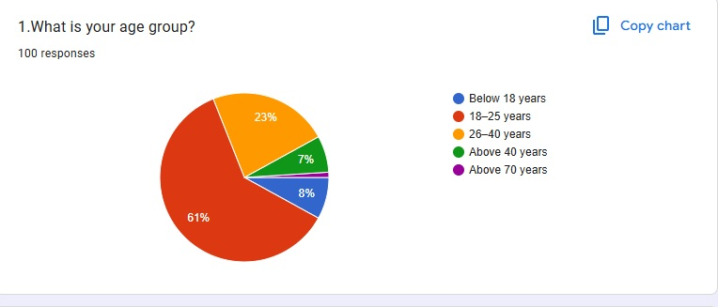

Question 2
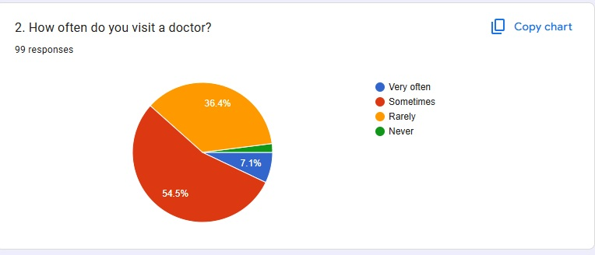

Question 3
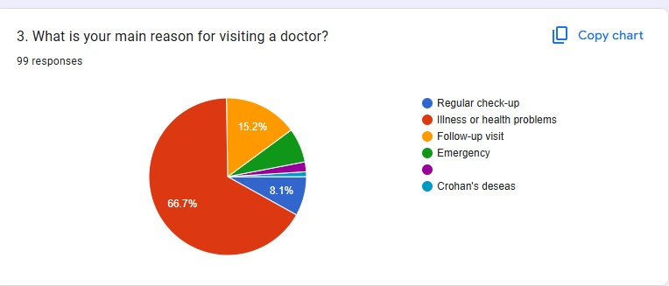

Question 4
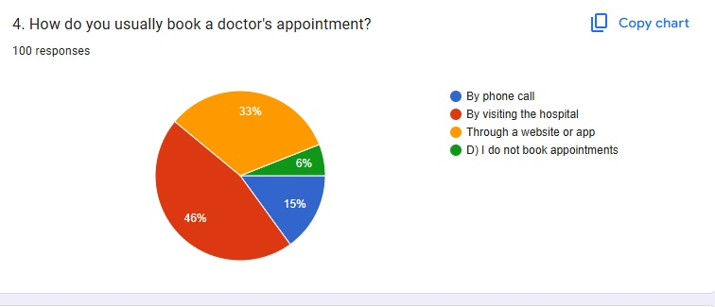

Question 5
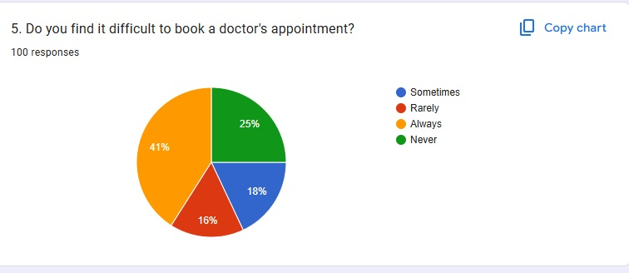

Question 6
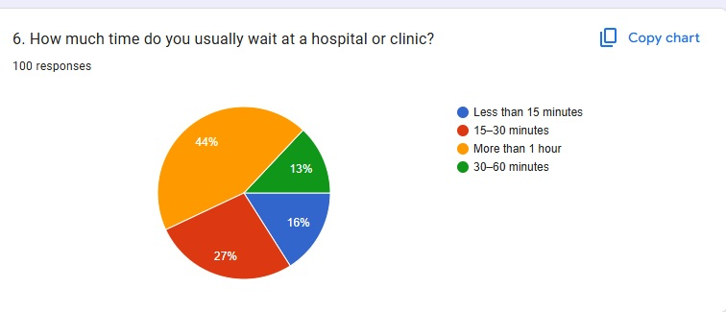

Question 7
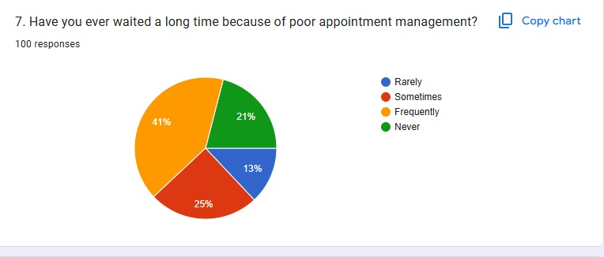

Question 8
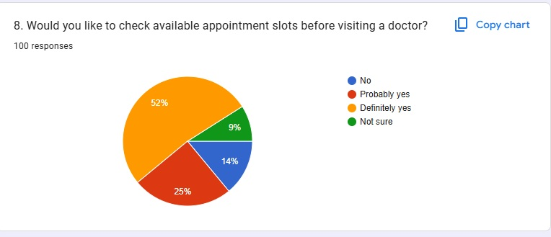

Question 9
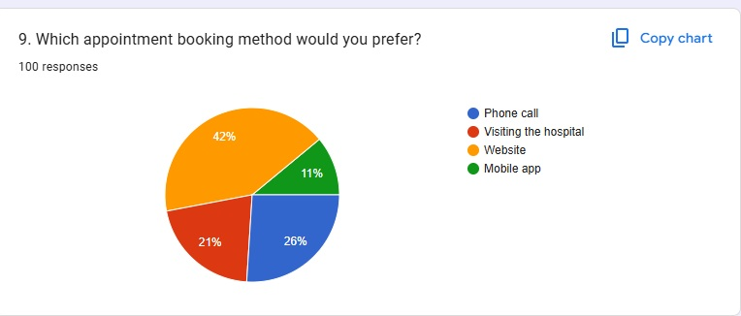

Question 10
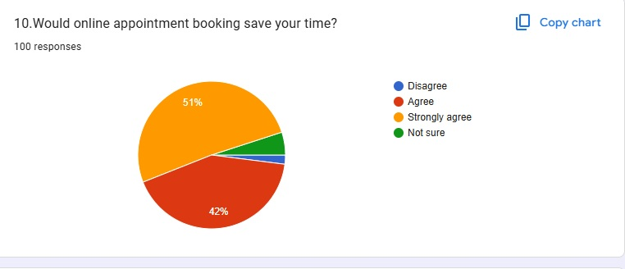

Question 11
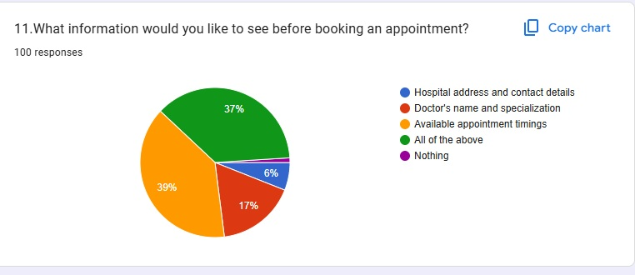

Question 12
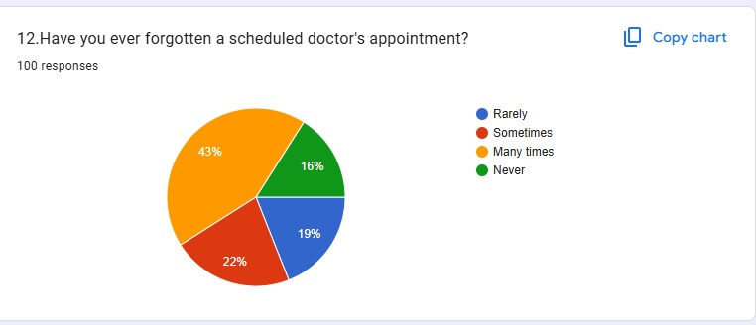

Question 13
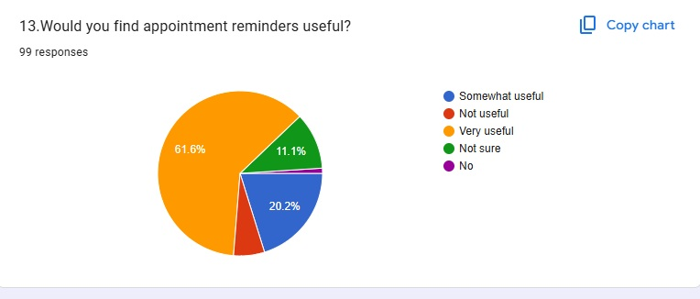

Question 14
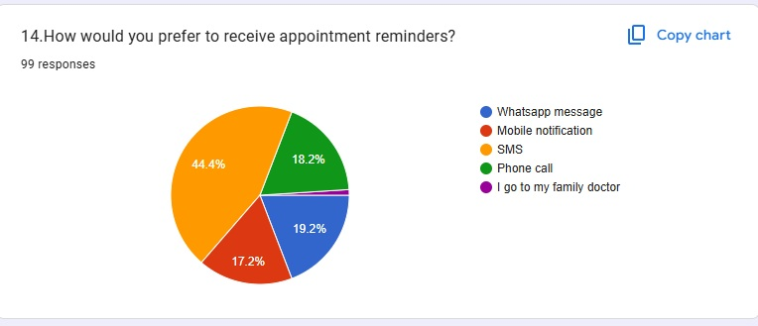

Question 15
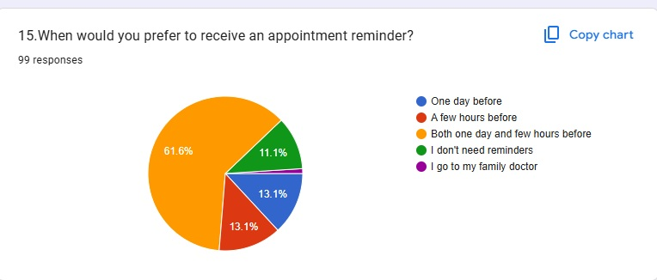

Question 16
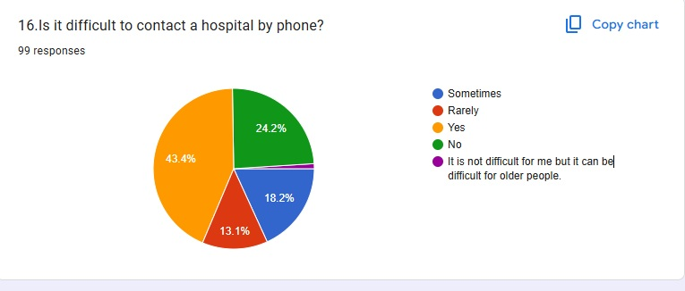

Question 17
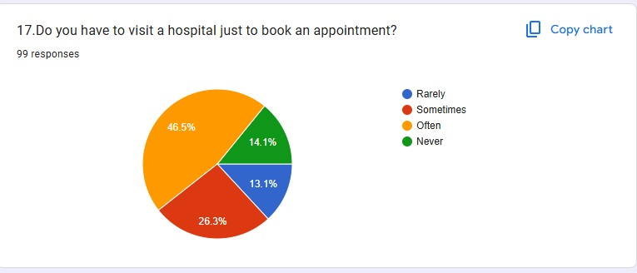

Question 18
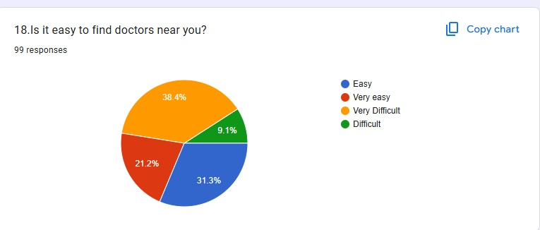

Question 19
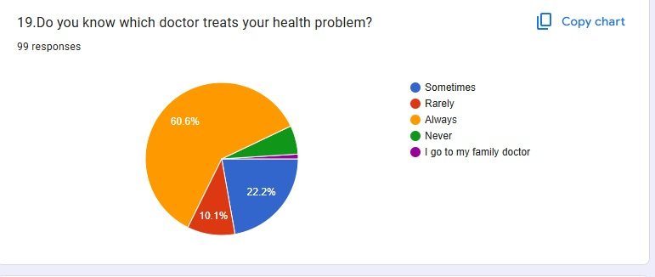

Question 20
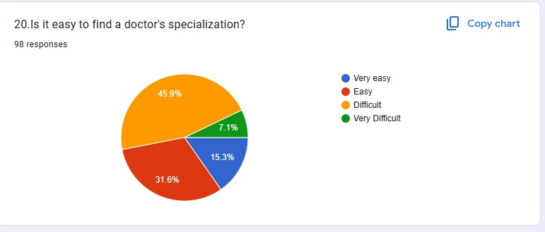

Question 21
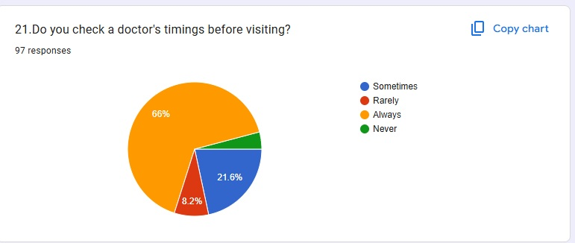

Question 22
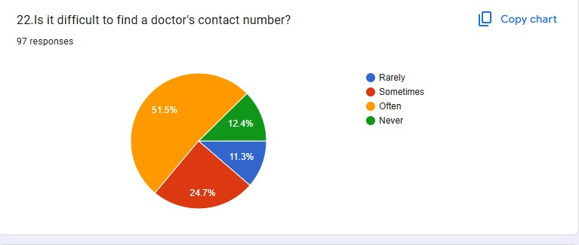

Question 23
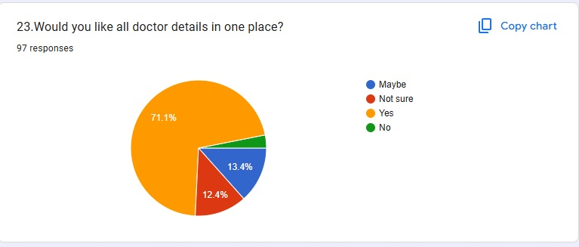

Question 24
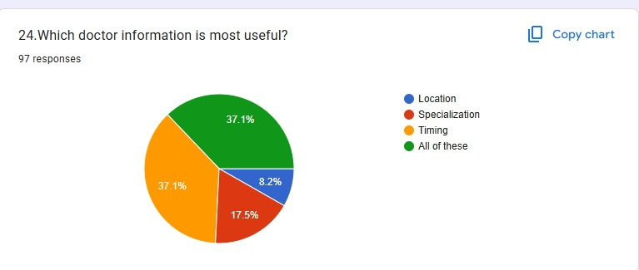

Question 25
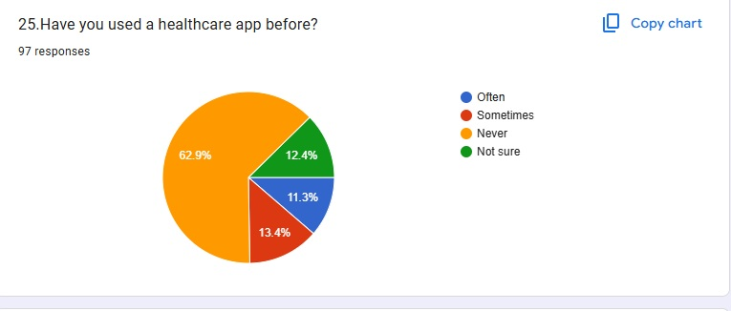

Question 26
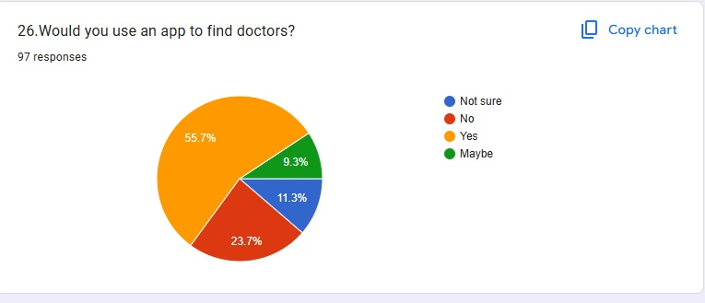

Question 27
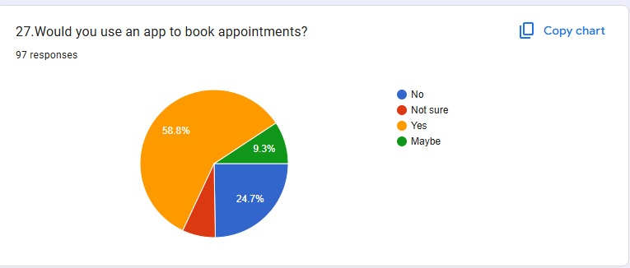

Question 28
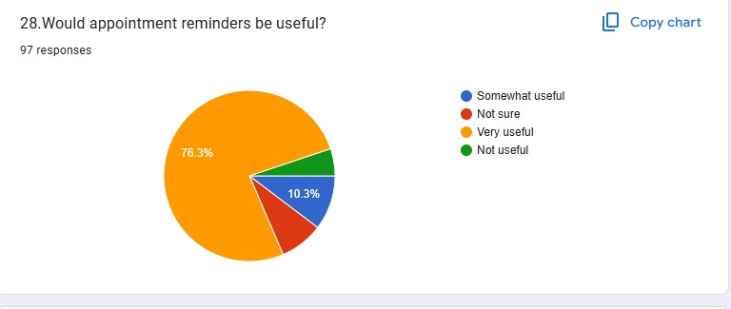

Question 29
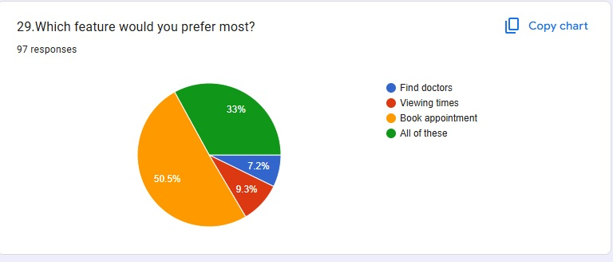

Question 30
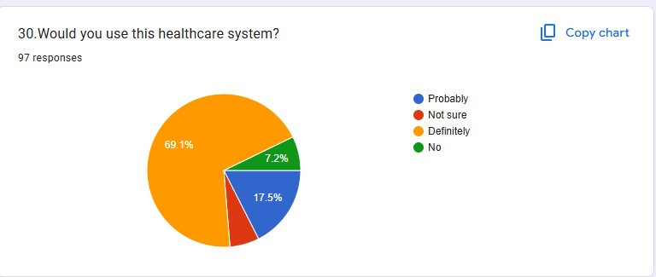

Chapter: 7 Result
1. What is your age group?
Result: The highest number of respondents (61%) selected “18–25 years”.
2. How often do you visit a doctor?
Result: The highest number of respondents (54.5%) selected “Sometimes”.
3. What is your main reason for visiting a doctor?
Result: The highest number of respondents (66.7%) selected “Illness or health problems”.
4. How do you usually book a doctor's appointment?
Result: The highest number of respondents (46%) selected “By visiting the hospital”.
5. Do you find it difficult to book a doctor's appointment?
Result: The highest number of respondents (41%) selected “Always”.
6. How much time do you usually wait at a hospital or clinic?
Result: The highest number of respondents (44%) selected “More than 1 hour”.
7. Have you ever waited a long time because of poor appointment management?
Result: The highest number of respondents (41%) selected “Frequently”.
8. Would you like to check available appointment slots before visiting a doctor?
Result: The highest number of respondents (52%) selected “Definitely yes”.
9. Which appointment booking method would you prefer?
Result: The highest number of respondents (42%) selected “Website”.
10. Would online appointment booking save your time?
Result: The highest number of respondents (51%) selected “Strongly agree”.
11. What information would you like to see before booking an appointment?
Result: The highest number of respondents (39%) selected “Available appointment timings”.
12. Have you ever forgotten a scheduled doctor's appointment?
Result: The highest number of respondents (43%) selected “Many times”.
13. Would you find appointment reminders useful?
Result: The highest number of respondents (61.6%) selected “Very useful”.
14. How would you prefer to receive appointment reminders?
Result: The highest number of respondents (44.4%) selected “SMS”.
15. When would you prefer to receive an appointment reminder?
Result: The highest number of respondents (61.6%) selected “Both one day and few hours before”.
16. Is it difficult to contact a hospital by phone?
Result: The highest number of respondents (43.4%) selected “Yes”.
17. Do you have to visit a hospital just to book an appointment?
Result: The highest number of respondents (46.5%) selected “Often”.
18. Is it easy to find doctors near you?
Result: The highest number of respondents (38.4%) selected “Very Difficult”.
19. Do you know which doctor treats your health problem?
Result: The highest number of respondents (60.6%) selected “Always”.
20. Is it easy to find a doctor's specialization?
Result: The highest number of respondents (45.9%) selected “Difficult”.
21. Do you check a doctor's timings before visiting?
Result: The highest number of respondents (66%) selected “Always”.
22. Is it difficult to find a doctor's contact number?
Result: The highest number of respondents (51.5%) selected “Often”.
23. Would you like all doctor details in one place?
Result: The highest number of respondents (71.1%) selected “Yes”.
24. Which doctor information is most useful?
Result: The highest number of respondents (37.1% each) selected “Timing and All of these”.
25. Have you used a healthcare app before?
Result: The highest number of respondents (62.9%) selected “Never”.
26. Would you use an app to find doctors?
Result: The highest number of respondents (55.7%) selected “Yes”.
27. Would you use an app to book appointments?
Result: The highest number of respondents (58.8%) selected “Yes”.
28. Would appointment reminders be useful?
Result: The highest number of respondents (76.3%) selected “Very useful”.
29. Which feature would you prefer most?
Result: The highest number of respondents (50.5%) selected “Book appointment”.
30. Would you use this healthcare system?
Result: The highest number of respondents (69.1%) selected “Definitely”.

7.1 Discussion

7.2 Discussion of Survey Findings
The survey responses indicate interest in a digital healthcare appointment platform. Respondents highlighted appointment booking difficulties, waiting time, access to doctor information, and the usefulness of reminders. The findings support the need for a simple and accessible appointment system.
A successful implementation should allow a patient to complete a booking with clear feedback, help staff see the day’s schedule, and stop two active bookings from occupying the same doctor’s slot. The system should also provide clear messages when a slot is no longer available or when required information is missing.

7.3 Functional Result Criteria
The system can be evaluated against the following criteria: patients can register and log in; doctor details can be searched; available slots are displayed; valid bookings are saved; unavailable slots are rejected; booking status can be viewed; cancellation changes the status correctly; and unauthorized users cannot access restricted functions.

7.4 Discussion
A centralized appointment record can reduce dependence on paper registers and separate messages. The largest benefit is likely to come from keeping availability accurate and making the booking process understandable. If staff do not update schedules, the digital calendar may become inaccurate and users may lose confidence in it.

A second important issue is accessibility. Some users may need help with digital forms, may have limited internet access, or may prefer a local language. A system should therefore be designed for mobile screens, use simple wording, and provide a support route for users who cannot complete a booking independently.
Privacy and trust are also essential. The system should explain why information is requested, limit data collection, and provide suitable security. Appointment booking should not be presented as emergency care; users facing an emergency must be directed to local emergency services.

The table lists test scenarios that should be executed during implementation. The expected results are acceptance criteria, not evidence that the tests have already passed. A completed project should record actual output, pass/fail status, defects found, and corrections made.

Chapter: 8 Recommendations and Future Work

8.1 Recommendations
Keep the first version focused on essential tasks: doctor search, availability, booking, cancellation, and staff schedule management. A small, reliable feature set is easier to test and maintain than a large system with unfinished features.
Maintain accurate doctor schedules. Provide authorized staff with a simple way to mark leave, block unavailable times, and change clinic hours. Display the time zone and date clearly, and ask users to review booking details before final submission.
Use clear appointment statuses such as Pending, Confirmed, Cancelled, and Completed. Send a confirmation message only when the system has actually saved the appointment. If messaging services are added, protect contact details and provide a way to correct them.
Follow privacy-by-design principles. Collect only the details needed for appointment management, use secure password handling, apply role-based access, protect data in transit, and maintain backups. Define how long records are kept and who is allowed to export them.
Test the interface with real intended users before wider use. Ask participants to find a doctor, book a slot, and cancel an appointment. Record where they hesitate, what errors occur, and whether they understand the confirmation screen.

8.2 Future Work
Possible future development includes SMS or email reminders, calendar integration, multilingual support, accessible text sizing, teleconsultation links, online payment through a trusted provider, and integration with a clinic’s existing information system. These should be added only after core scheduling works correctly.

A future version could provide waiting-list support when a slot becomes available, basic reports on appointment volume, and analytics that help clinics plan staffing. Any analytics should use appropriate safeguards and should not expose personal health information unnecessarily.

Artificial intelligence could be considered for administrative assistance, such as suggesting appointment slots based on user preferences. It should not be used to diagnose patients or make clinical decisions without appropriate validation, oversight, and regulatory review.

Chapter: 9 Suggestion

The following suggestions can improve the usefulness and reliability of the Smart Healthcare Appointment System.

- Simple Registration: Keep the registration form short and ask only for essential information. Clearly explain why each required field is needed.

- Accurate Availability: Make doctor schedules easy to update and immediately reflect changes in the booking interface.

- Booking Confirmation: Display the doctor’s name, clinic location, date, time, and booking reference after successful booking.

- Reminders: Offer optional reminders before an appointment, with user consent and an easy way to update contact information.

- Cancellation and Rescheduling: Explain the clinic’s rules and make it easy to release a slot when a patient cannot attend.

- Accessibility: Use readable fonts, strong contrast, keyboard-friendly controls, and simple language. Considerlocal-language labels and mobile-first design

- Security: Use secure authentication, role permissions, protected connections, backups, and audit logs for important administrative actions.

- Support: Provide clinic contact details or a help option for users who have difficulty using the system.

- Feedback: Collect feedback after a booking task and use it to improve navigation, labels, and error messages.

- Emergency Notice: State clearly that the appointment system is not an emergency service and cannot replace urgent medical care.

Chapter: 10 Conclusion

The Smart Healthcare Appointment System is a proposed digital solution for organizing the process of booking and managing healthcare appointments. It aims to make doctor availability easier to view, reduce repetitive manual scheduling work, and maintain appointment information in a structured form.

The report has described the background, problem statement, scope, objectives, related concepts, methodology, proposed workflow, testing criteria, recommendations, and future possibilities. The system’s core features are patient access, doctor search, availability management, booking, appointment status, and cancellation or rescheduling.

The benefits described in this report are expected outcomes and have not been confirmed through a live deployment or a completed survey. To establish actual effectiveness, the system should be implemented, tested with intended users, and evaluated using clearly defined measures such as successful booking rate, time taken to complete tasks, scheduling errors, and user satisfaction.

In conclusion, a simple, secure, accessible, and well-maintained appointment system can support better coordination between patients and healthcare providers. Its value will depend on accurate information, privacy protection, user-friendly design, and ongoing feedba ck from the clinic and its patients.

References

The following references provide starting points for understanding digital health, privacy, usability, and software design. Access dates and exact document versions should be checked before final academic submission.

- World Health Organization (WHO). Global strategy on digital health 2020–2025. https://www.who.int/health-topics/digital-health

- Ministry of Health and Family Welfare, Government of India. Official health programme and digital health information. https://mohfw.gov.in/

- National Health Authority, Government of India. Ayushman Bharat Digital Mission. https://abdm.gov.in/

- https://owasp.org/www-project-top-ten/?utm_source=chatgpt.comW3C. Web Content Accessibility Guidelines (WCAG) . https://www.w3.org/WAI/standards-guidelines/wcag/

- Pressman, R. S. and Maxim, B. R. Software Engineering: A Practitioner's Approach. McGraw-Hill.

- Sommerville, I. Software Engineering. Pearson.

- MySQL Documentation. https://dev.mysql.com/doc/

- MDN Web Docs. HTML, CSS, JavaScript, and web development guides. https://developer.mozilla.org/

- Project design notes and requirements prepared for the proposed Smart Healthcare Appointment System.

Chapter: 11 Questionnaire
Please select the most appropriate option for each question.
1. What is your age group?
A. Below 18 years
B. 18–25 years
C. 26–40 years
D. Above 40 years
2. How often do you visit a doctor?
A. Very often
B. Sometimes
C. Rarely
D. Never
3. What is your main reason for visiting a doctor?
A. Regular check-up
B. Illness or health problems
C. Follow-up visit
D. Emergency
4. How do you usually book a doctor's appointment?
A. By phone call
B. By visiting the hospital
C. Through a website or app
D. I do not book appointments
5. Do you find it difficult to book a doctor's appointment?
A. Sometimes
B. Rarely
C. Always
D. Never
6. How much time do you usually wait at a hospital or clinic?
A. Less than 15 minutes
B. 15–30 minutes
C. More than 1 hour
D. 30–60 minutes
7. Have you ever waited a long time because of poor appointment management?
A. Rarely
B. Sometimes
C. Frequently
D. Never
8. Would you like to check available appointment slots before visiting a doctor?
A. No
B. Probably yes
C. Definitely yes
D. Not sure
9. Which appointment booking method would you prefer?
A. Phone call
B. Visiting the hospital
C. Website
D. Mobile app
10. Would online appointment booking save your time?
A. Disagree
B. Agree
C. Strongly agree
D. Not sure
11. What information would you like to see before booking an appointment?
A. Hospital address and contact details
B. Doctor's name and specialization
C. Available appointment timings
D. All of the above
12. Have you ever forgotten a scheduled doctor's appointment?
A. Rarely
B. Sometimes
C. Many times
D. Never
13. Would you find appointment reminders useful?
A. Somewhat useful
B. Not useful
C. Very useful
D. Not sure
14. How would you prefer to receive appointment reminders?
A. WhatsApp message
B. Mobile notification
C. SMS
D. Phone call
15. When would you prefer to receive an appointment reminder?
A. One day before
B. A few hours before
C. Both one day and few hours before
D. I don't need reminders
16. Is it difficult to contact a hospital by phone?
A. Sometimes
B. Rarely
C. Yes
D. No
17. Do you have to visit a hospital just to book an appointment?
A. Rarely
B. Sometimes
C. Often
D. Never
18. Is it easy to find doctors near you?
A. Easy
B. Very easy
C. Very Difficult
D. Difficult
19. Do you know which doctor treats your health problem?
A. Sometimes
B. Rarely
C. Always
D. Never
20. Is it easy to find a doctor's specialization?
A. Very easy
B. Easy
C. Difficult
D. Very Difficult
21. Do you check a doctor's timings before visiting?
A. Sometimes
B. Rarely
C. Always
D. Never
22. Is it difficult to find a doctor's contact number?
A. Rarely
B. Sometimes
C. Often
D. Never
23. Would you like all doctor details in one place?
A. Maybe
B. Not sure
C. Yes
D. No
24. Which doctor information is most useful?
A. Location
B. Specialization
C. Timing
D. All of these
25. Have you used a healthcare app before?
A. Often
B. Sometimes
C. Never
D. Not sure
26. Would you use an app to find doctors?
A. Not sure
B. No
C. Yes
D. Maybe
27. Would you use an app to book appointments?
A. No
B. Not sure
C. Yes
D. Maybe
28. Would appointment reminders be useful?
A. Somewhat useful
B. Not sure
C. Very useful
D. Not useful
29. Which feature would you prefer most?
A. Find doctors
B. Viewing times
C. Book appointment
D. All of these
30. Would you use this healthcare system?
A. Probably
B. Not sure
C. Definitely
D. No

